***ISLAMIC ECONOMICS SYSTEM***

* *Capitalism, Communism and Mixed Economics system has purely a materialistic approach in which human social life has no importance.*
* *But in Islamic System the followers of Islam are required to lead a material life in such way that it becomes a source of happiness and respect of others in this world for making secure himself for next world.*
* »سرمایہ داری، اشتراکیت اور مخلوط اقتصادیاتکا نظام خالصتا ایک مادی نقطہ نظر ہے,جس میں انسان کی سماجی زندگی کی کوئی اہمیت نہیں ہے.لیکن اسلامی نظامکے مطابق اسلام کے پیروکاروں کوایسی مادی زندگی گزارنی چاہئے کہ جو اس دنیا میں دوسروں کیخوشی اور عزت کا باعث بنے اوراپنیآخرت بھی محفوظ ہو جائے.
* *Islamic economic system consist of institutions, organizations and the social values by which natural, human and man-made resources are used to produce, exchange, distribute and consume wealth/Goods and services under the guiding principles of Islam to achieve "FALAH" in this world and also after it.*

***THE ECONOMIC PHILOSOPHY OF ISLAM***

* *The economic philosophy of Islam has no concept of Riba because according to Islam, Riba is that curse in society, which accumulates money around handful of people, and it results inevitably in creating monopolies, opening doors for selfishness, greed, injustice and oppression.*
* *Deceit and fraud prospers in the world of trade and business.*
* *Islam, on the other hand, primarily encourages highest moral ethics such as universal brotherhood, collective welfare and prosperity, social fairness and justice.*
* *Due to this reason, Islam renders Riba as absolutely haram and strictly prohibits all types of interest based transactions.*
* *Business groups & companies whose objective is not public benefit; they can hoard or burn extra food material to control price, which causes serious moral decline.*

» اسلامی اقتصادی نظام اداروں، تنظیموں اور سماجیاقدارپر مشتملہےجس کے ذریعے قدرتی، انسانی اور مصنوعی وسائلکا استعمال، تبادلے، تقسیم اور اشیاء و خدمات کے استعمالکی پیداوار اسلام کے رہنماء اصول کے مطابق ہوتی ہے تاکہ اس دنیا میں اور

اس کے بعد بھی فلاح حاصل ہو.

***ACCORDING TO MATERIALISTIC***

***ECONOMICS***

**مادی معاشیات کے مطابق:**

***"Livelihood is the fundamental problem of man and economic developments are the ultimate end of human life"***

**"زریعہ معاش انسان کا بنیادی مسئلہ ہے اور اقتصادی ترقی انسانی زندگی کا حتمی اختتام ہے"**

***WHILE ACCORDING TO ISLAMIC ECONOMICS:***

***“Livelihood may be necessary and indispensable, but cannot be the true purpose of human life"***

**" زریعہ معاش ضروری اور ناگزیر ہو سکتا ہے، لیکن انسانی زندگی کا حقیقی مقصد نہیں ہو سکتا"**

***The Holy Quran has enunciated this basic truth very precisely in a brief verse:***

**قرآن مجید میں ایک مختصر آیت میں بہت واضح طور پر اس حقیقت”“کا اعلان کیا گیا ہے**

***WHILE ACCORDING TO ISLAMIC ECONOMICS:***

***"But seek, through that which Allah has given you, the home of the Hereafter; and [yet], do not forget your share of the world. And do good as Allah has done good to you. And desire not corruption in the land. Indeed, Allah does not like corrupters." you" (28:77)***

***(Sura  Al-Qasas)***

***BASIC CONCEPTS OF ISLAMIC ECONOMICS SYSTEM***

*1. The Concept of Private Property* **1- نجی ملکیت کے تصور**

*2. Consumption of wealth* **2. مال کی کھپت** *3. Production of wealth* **3. دولت کی پیداوار** *4. Distribution of wealth* **4. دولت کی تقسیم** *5. The concept of Zakat* **5. زکوة کا تصور** *6. Interest free Economy (Riba)* **6. آزاد معیشت**

*7. Economic Growth* **7. اقتصادی ترقی**

*8. Responsibilities of the Government.* **8. حکومت کی ذمہ داریاں.**

***1. The Concept of Private Property***  
*Basic Principles in Islam for Consumption or Investment of private property are:   
  
 Concept of "HALAL" and "HARAM" for earning or in production and consumption of wealth.   
A property cannot be used against public interest.   
Show much as you have something.   
Real/money Capital cannot be used for gain.   
Payment of Zakat is compulsory.*

***2. Consumption of Wealth***

*In Islamic System uses of luxuries are not allowed because it against the concept of "TAQWA" should have distinguish between "HALAL" and "HARAM"."BUKHAL" and "ISRAF" are to be avoided*

***3. Production of Wealth***

*Price mechanism plays a key role in carrying out the production process in an Islamic Society. As Price system results in the expectations of workers and consumers the Govt. Interferences with the price mechanism to over come the problem. These things are not allowed in Islamic System.   
Production of drugs, gambling, lottery, music, dance etc.   
Lending and borrowing on interest   
Black marketing, Smuggling etc.*

***4. Distribution of Wealth***

* *Islamic Economics System favor fair (not equal) distribution of wealth in the sense that it should not be confined to any particular section of the society. For fair distribution of wealth Islam gives following steps*
* *BUKHAL" and "ISRAF" are to be avoided.*
* *Payment of Zakat*
* *Interest not allowed*
* *Monopoly of Private firm not allowed*
* *Earning from Black Market.*

***5. The Concept of Zakat***

*Zakat is a major source of revenue the government in an Islamic state. It levy on all goods and money or on wealth if have to pay yearly on the month of RAJAB or RAMADAN.*

***6. Interest free Economy***

*The whole financial system the bank structure in particular is run on the basis "SHARAKAT" and "MUZARABAT" in Islamic state. Therefore, Islamic economics is an interest free economy.*

***7. Responsibility of theGovernment***

*Responsibility of the Islamic Government are   
1. Should Checkun Islamic activity like gambling, smuggling, black marketing etc.   
2. Should secure poor people by giving them necessity of life i.e. food, clothing, health etc.   
3. Should provide equal employment opportunity.   
4. Social and Economic Security is required to guaranteed by the Govt.*

***According to Quran***

***“****Establish worship, pay the poor- due, and bow your heads with those who bow (in worship)”(2:43)*Screen Clipping*(Surah Al-baqrah)*

*“O you who have believed, do not consume usury, doubled and multiplied, but fear Allah that you may be successful.” (3:130)*

*Screen Clipping(Surah-Ale-Imran)*

*“And of their usury when they were forbidden it, and of their devouring people’s wealth by false pretenses we have prepared for those of them who disbelieve a painful doom.” (4:161)*

*(Surah Al-Nisa)*

**

*“That which ye give in usury in order that it may increases on (other) people’s property hath no increase with ALLAH; but that which ye give in charity , seeking ALLH’s countenance ,hath increase manifold”. (30:39)*

*(Surah Al-Room)*

**

***Means Of Distribution of Wealth in Islam***

* **Zakat**
* Law of inheritance
* Law of will
* Law of Waqf
* Charity of Fitr
* Monetary atonements

**ּزکوة**

**ּوراثت کے قانون**

**ּوصیت**

**ּوقف مال کے قانون**

**ּفطرانہ**

**ּمالیاتی کفارہ**

***Verses on Zakat***

And establish prayer and give zakah and bow with those who bow [in worship and obedience].  
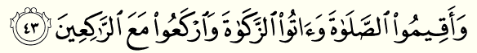*Surat Al-Baqarah*

Screen Clipping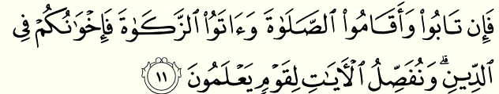

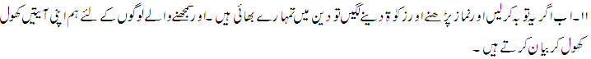

But if they repent, establish prayer, and give zakah, then they are your brothers in religion; and We detail the verses for a people who know.

Surat At-Tawbah

***Verses on Inheritance***

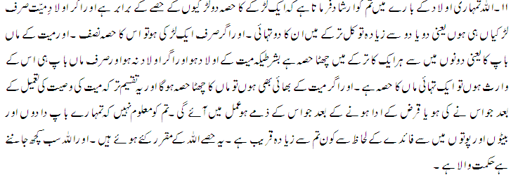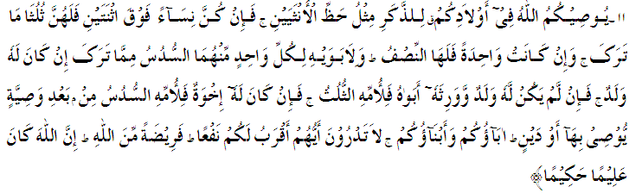

***ISLAMIC WAYS OF TRADE AND COMMERCE***

* *Make profit the secondary aim***.**
* *Be honest and truthful.*
* *Keep one’s word.*
* *Do not bribe.*
* *Do not sell the haram.*
* *Do not deal fraud.*
* ***MAKE PROFIT THE SECONDARY AIM:***
* *The first goal of a Muslim business should not be cashing in on a Muslim market. It should be pleasing Allah and establishing Halal as a way of life.*
* *Seeking profit is not a bad aim, but it should be secondary.*
* *Islam condemns hoarding to make high profit at the cost of public interest*
* ***BE HONEST AND TRUTHFUL:***
* *Islam guides us to be honest and truthful in every walk of life. Never take help of lie in your life, if every one is against of you on your truth then ALLAH will help you.*
* *Abdullah ibnMasood(r.a.a) relates that the Prophet  
  (s.a.w) said:*

***“A true action leads to the path of  
virtue and good deeds, and virtue paves the way of a  
person to Paradise, and the said person continues to  
speak the truth till in the sight of Allah he is named  
Siddiq (Truthful). lying leads to vice, and vice  
leads to indecent acts and a person goes on lying till  
in the sight of Allah he is named a liar.”***

*(Bukhari, hadith #54)*

* ***KEEP ONE’S WORD:***
* *Islam advice us to keep on our words. If we have made an agreement with some one to sale a specific thing in a specific price and after that we should not change our intension to sale the same thing to someone else with high price.*
* ***Allah says in Quran:***

***“And fulfill (every) covenant. Verily! The covenant will be questioned about.”  
(Surah Isrâ 17:34)***

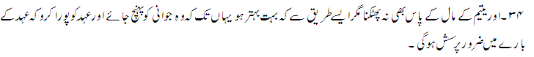

* ***DO NOT BRIBE:***
* *Islam highly restrict us to avoid bribe. Do not receive an do not pay bribe. Islam do not allow bribe in any condition.*
* *Abdullah bin Amr (RA) narrated that The Messenger of Allah (SAW) said:*

***“Allah cursed the briber (Rashi) and bribe-taker (Murtashi).”***

*(Hadith No. 1337, Chapters on Judgments, Jami’ At-Tirmidhi, Vol. 3)*

* ***DO NOT DEAL FRAUD:***
* *Islam prohibits every type of fraud and deception, whether it be in buying and selling or in any other matter between people. In all situations the Muslim must be honest and truthful, holding his faith dearer than any worldly gain. The Prophet (peace be on him) said,*

***“Why did you not put it on top so that the people could see it? He who deceives us is not of us.”***

***(Reported by Muslim, Hadith #*** *1579****).***

* ***DO NOT SELL THE HARAM:***
* *Islam prohibited the sealing and purchasing of Haram things. It may be meat, dugs and other thing that are harmful for health.*
* *ALLAH said in Quran that:*

***“O ye who believe! Eat of the good things wherewith We have provided you, and render thanks to Allah if it is (indeed) He whom ye worship”****(Surah Al-Baqarah #172).*

Screen Clipping

***CONCLUSION***

*After the deep study on Islamic Economic System it is concluded that Islam guide us in all directions of life. An Islamic Setup provides a graceful economic and social life. it distribute the wealth in all family. If we follow the Islamic system and spend our lives according to Quran and Sunnah than we don’t have any problem in our lives.*